Outstanding issues for main conservatory
Michael Atkinson 33 Railway Terrace, Fitzwilliam WF9 5DB.
# | Issue | Category | Where? | Evidence
1 | Plaster does not meet up to the end of the shelf. It’s just a nuisance item that once it’s seen it can’t be unseen. Could be fixed with some filler that can be painted over. | Cosmetic Issue | To the left of the front door | 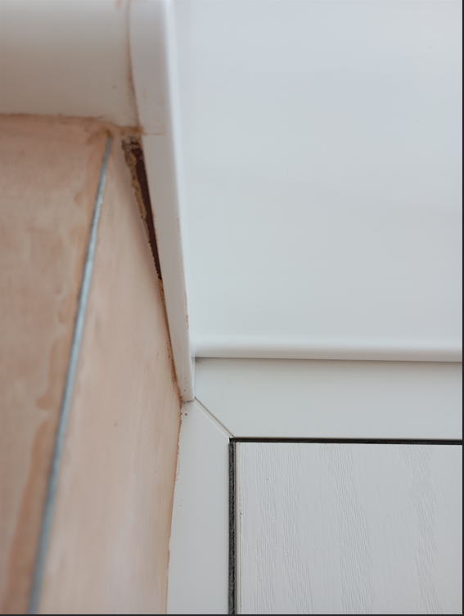
2 | Pointing needs tidying at the front | Cosmetic Issue | Outside the front door on joining wall.  Fixed: 21 October 2025 | 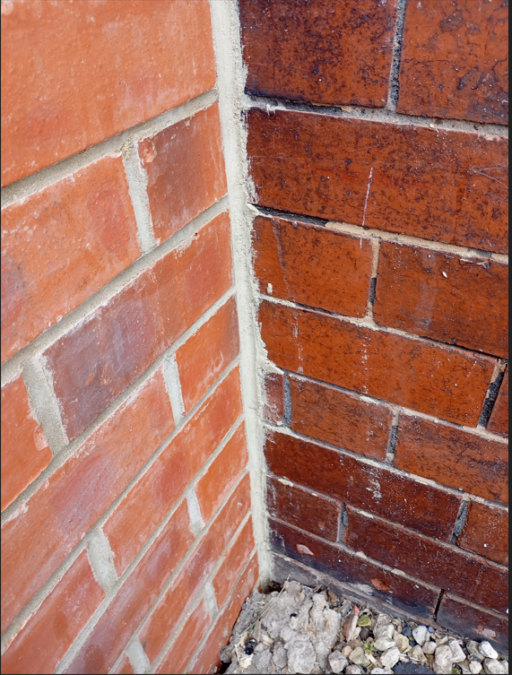
3 | Brick has residual cement. These are beautiful engineering bricks, but the effect is spoiled by not being clean. Muric acid? | Cosmetic Issue | Front, side and back walls  Fixed: 21 October 2025 | 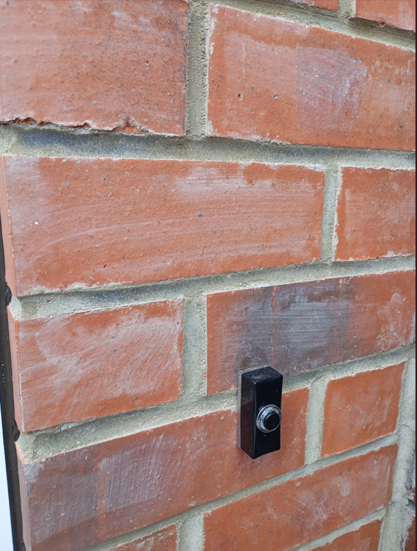
4 | Brick has residual cement on joint with existing wall and copper gas pipe. | Cosmetic Issue | Back wall (see item 3)  Fixed: 21 October 2025 | 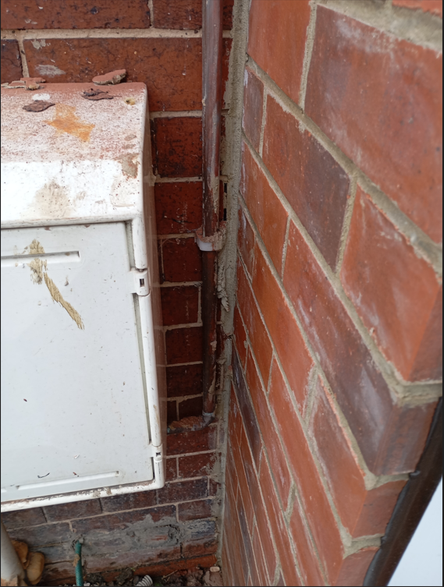
5 | Tramlines in the concrete has caused flooring contractors to quote for grinding of the floor to make it suitable for floor coverings. | Additional Cost to customer. | Concrete floor inside the conservatory  Fixed: 21 October 2025  Fix shown by a contractor to be substandard 28 October 2025 (see | 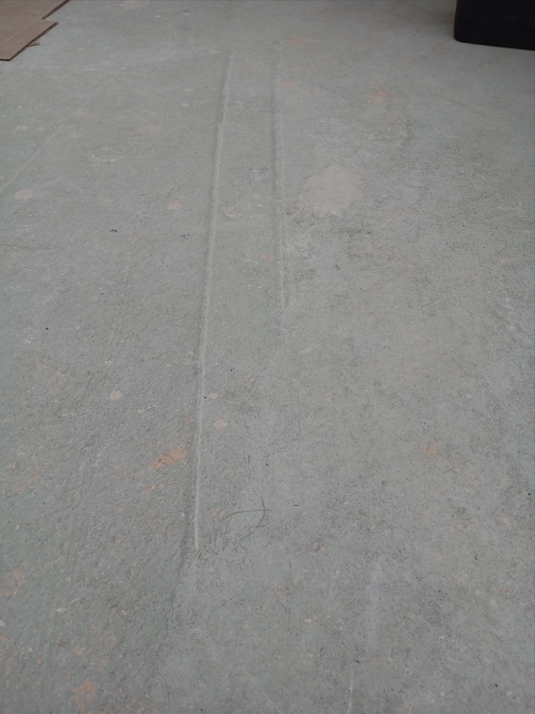
6 | Spilled and dried plaster or cement has caused flooring contractors to quote for grinding of the floor to make it suitable for floor coverings. | Additional Cost or effort to customer. | Concrete floor inside the conservatory  Fixed: 21 October 2025 | 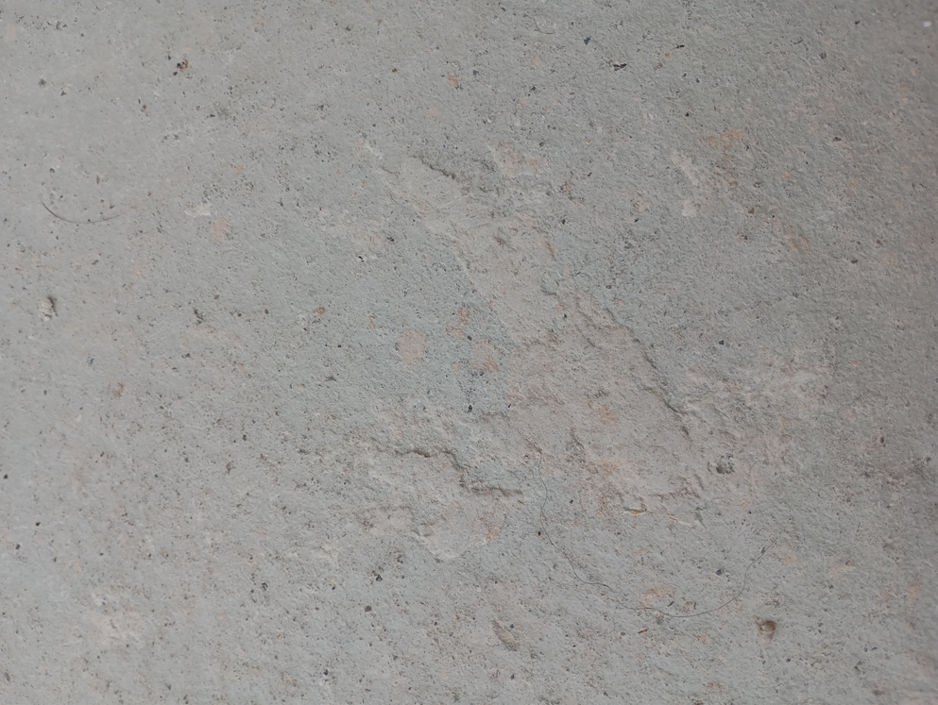
7 | Tramlines in the concrete has caused flooring contractors to quote for grinding of the floor to make it suitable for floor coverings. | Additional Cost to customer. | Concrete floor inside the conservatory (see item 5)  Fixed: 21 October 2025 | 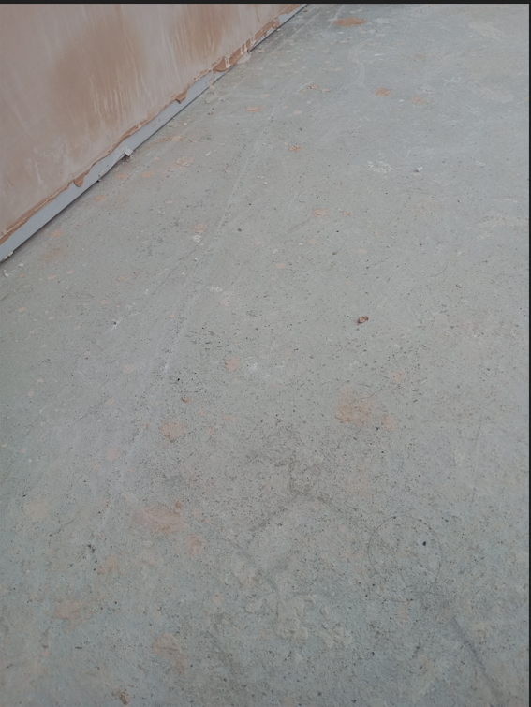
8 | Informed of drain issue | Sewage issue | Outside small conservatory | Evidence provided; being prioritised.  21 October 2025: Builder confirms that the drain will be sorted within the next 2 weeks. It’s agreed that a ‘soakaway’ will be provided. All wood and debris is to be moved before installation.
9 | Substandard flooring (see #5,6,7). The floor that appeared to have been screeded to almost 2 days to dry, and when it was dry it cracked in a few places. Flooring expert stated he couldn’t fix LVT flooring as the surface was substandard and scraped the surface which turned to powder. There were also lumps in this mixture. | Inadequate fix | Large conservatory floor | 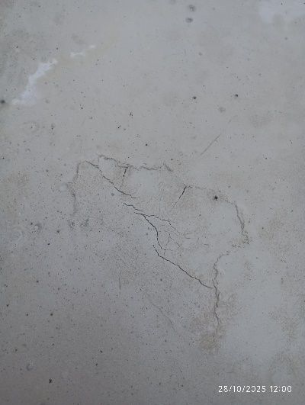
9a | 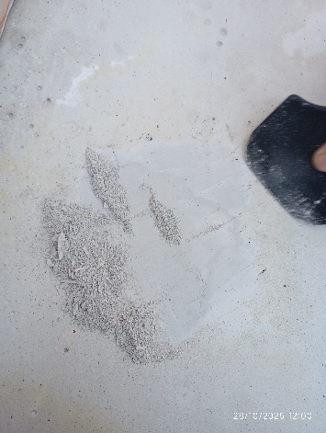 | 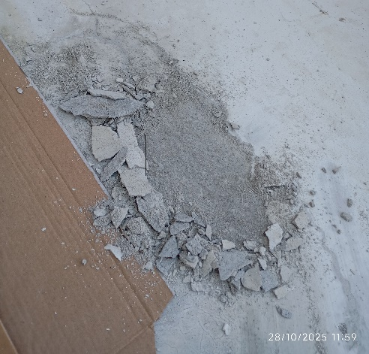 | 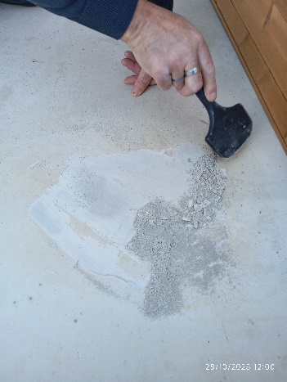 | 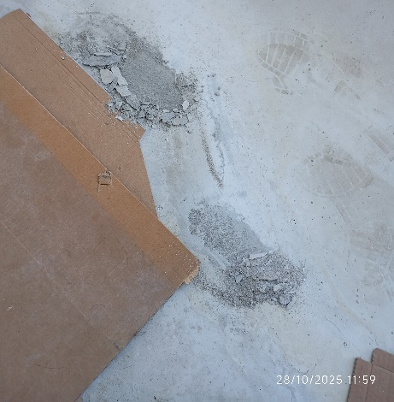
Pictures are compressed and can be expanded by grabbing the corner with the mouse pointer and stretching out:
