# | Issue | Category | Where? | Evidence
11 | As a consequence of the abandoned soakaway work, the gravel part of the drive was dug up. | Legacy Issue | Drive; gravel needs to be moved and hole in the ground reinstated for car to park. | 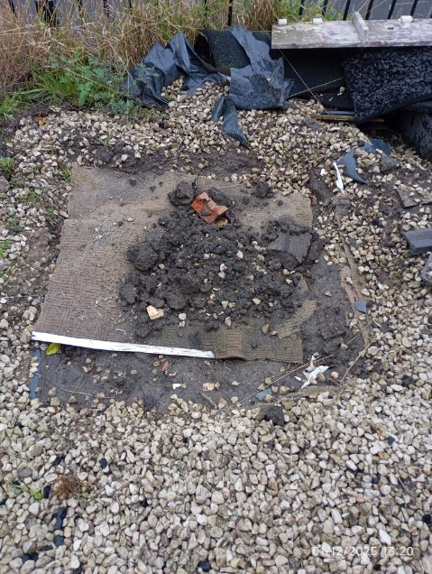
12 | Front door difficult to lock | Legacy Issue | The door at the side of the conservatory, used as the front door out of the house is difficult to lock most of the time; it can take up to five minutes to lock it properly. | See video on web page
13 | Broken rubber seal at the foot of door | Other conservatory, sealing issue. Please note, this is the first, smaller conservatory. | It is known that this issue is caused by a loose screw (pictured). | 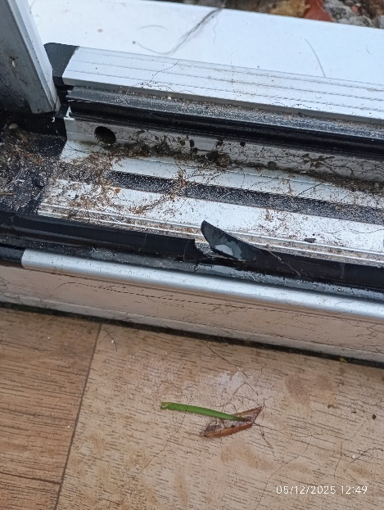
13 |  | 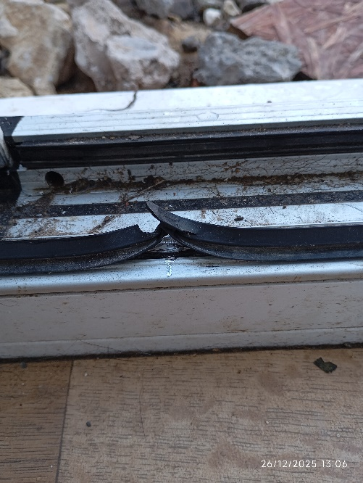 | 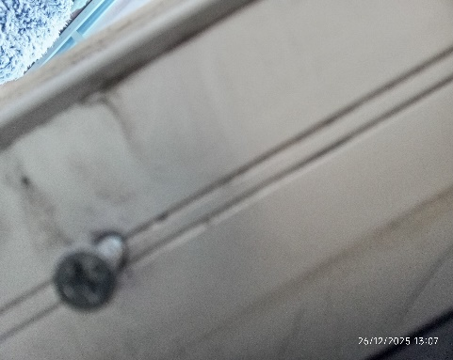 | 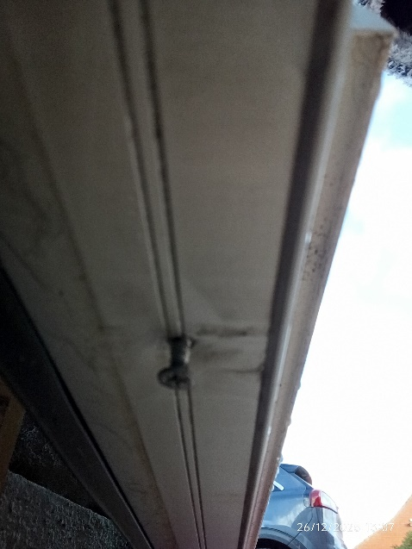
14 | Heater is not a new item. The heater was fitted to the wall by the electrician but when removed was battered. It seems that the heater was used by another customer (and was purchased as a new item), or some damage to it had occurred during transit before it was fitted. We did not know about this until it was taken off the wall for wall-painting. | Legacy Issue. | Larger conservatory | 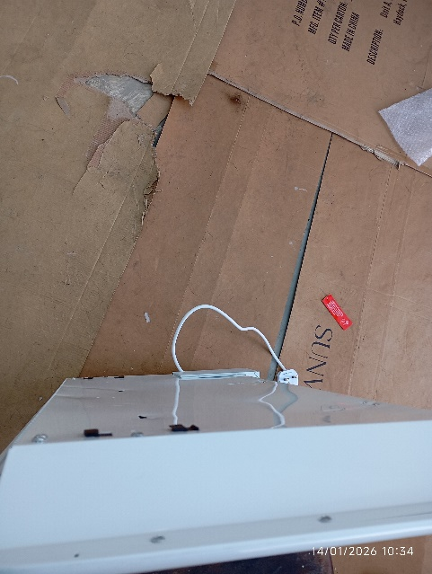
14 |  | 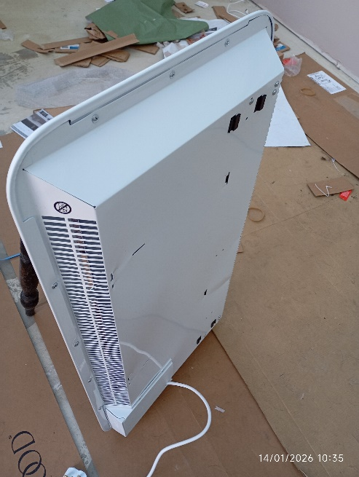 | 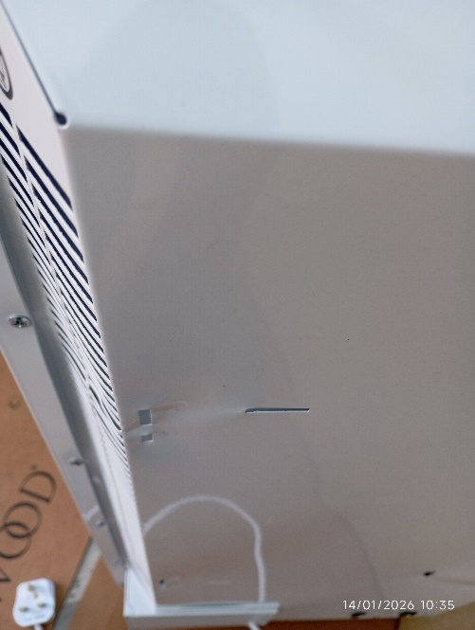 | 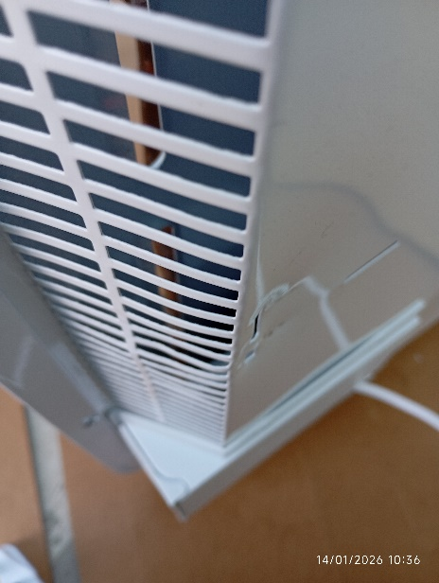
Pictures are compressed and can be expanded by grabbing the corner with the mouse pointer and stretching out:
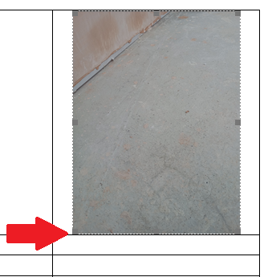
Outstanding issues for main and smaller conservatories
Michael Atkinson 33 Railway Terrace, Fitzwilliam WF9 5DB. Both conservatories are fully paid for as of 5th December 2025.

